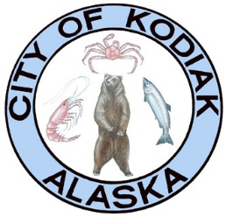

Kodiak Area Emergency Services Organization
Issued April 23, 2020

BUSINESS REOPENING
MITIGATION PLAN INSTRUCTIONS

The following mitigation document is to help you in reopening your business in Kodiak, Alaska. Per State of Alaska Health Mandate 16 Attachments D-H, one of the requirements for businesses to reopen is to establish a COVID-19 Mitigation Plan. The intent of the Mitigation Plan is to ensure that businesses can remain open while keeping the community safe.

To help keep Kodiak safe, we are asking businesses to submit a Worker Mitigation Plan to the Emergency Operations Center Safety Officer.

To assist businesses, we have created a template, the Kodiak Re-Opening COVID-19 Worker Mitigation Plan. Businesses can insert their information in the yellow-highlighted areas of the template. Fill in the circles “O” on the form to indicate whether or not your business will implement the protective measure. Alternative, you can create your own plan and use the template as guidance.

Upon completion of this document or plan return the document to: Safety@city.kodiak.ak.us and a Mitigation Receipt Number will be sent to you.

Parts of the document may or may not apply to your business, trade, profession or commerce. The intent is to work with you and give you a framework for meeting the State of Alaska’s Mandate Number 16 as ordered by Governor Dunleavy. Our community goal is to help prevent the spread of the CORVID-19 VIRUS.

Kodiak Area Emergency Services Organization
Reopening Kodiak Responsibly

COVID-19 (Coronavirus) Mitigation Action Plan for business reopening.
Company Name: _________________________________________
Authorized Representative: _________________________________
Mitigation Receipt Number: ____________

This Business has Submitted and Received Mitigation Plan Acceptance

Any person with symptoms consistent with COVID-19 may not enter the premises.
Upon Receipt of a Mitigation Receipt Number Place this in your store front.

